# Surface Science Simulation Instructions

Overview

Instructions 2

Download MATLAB 2

Download Files 2

Run Simulations 3

Simulation Overview 4

Simulation Specific Instructions 5

References 8

# Instructions

### Download MATLAB

MATLAB is free to all Princeton students. It may be downloaded by following the instructions here:

<http://www.princeton.edu/software/licenses/software/matlab/>

NOTE: MATLAB is also installed/available for students to use on any of the public computers in the Engineering Library.

### Download Files

There are four simulations:

1. TPD.m
2. Layer.m
3. Langmuir.m
4. Sticking.m

### Run Simulations

Open the desired mfile. Matlab should open and your screen will appear as shown in Figure 1. To start the simulation, press the green “run” button, circled in Figure 1.

If you see a Dialog Box, click the “Add to Path” button.

This should open a new window entitled “Figure 1”.

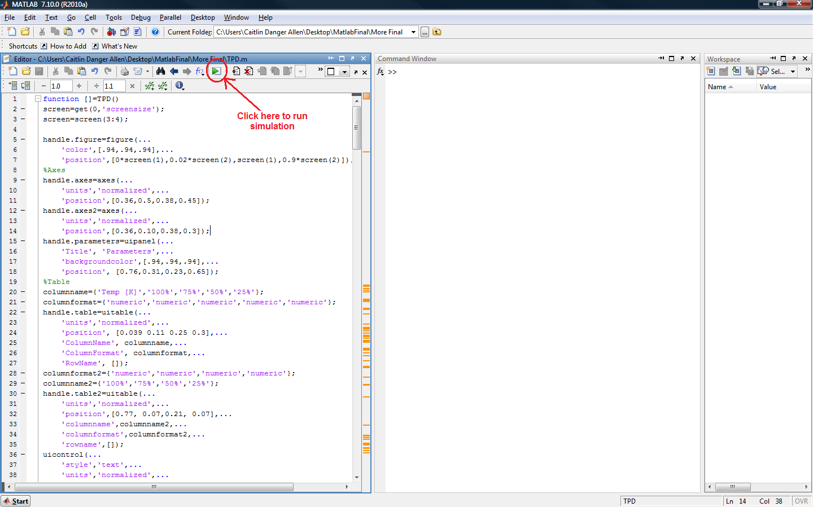

**Figure 1 - Simulation start up**

### Simulation Overview

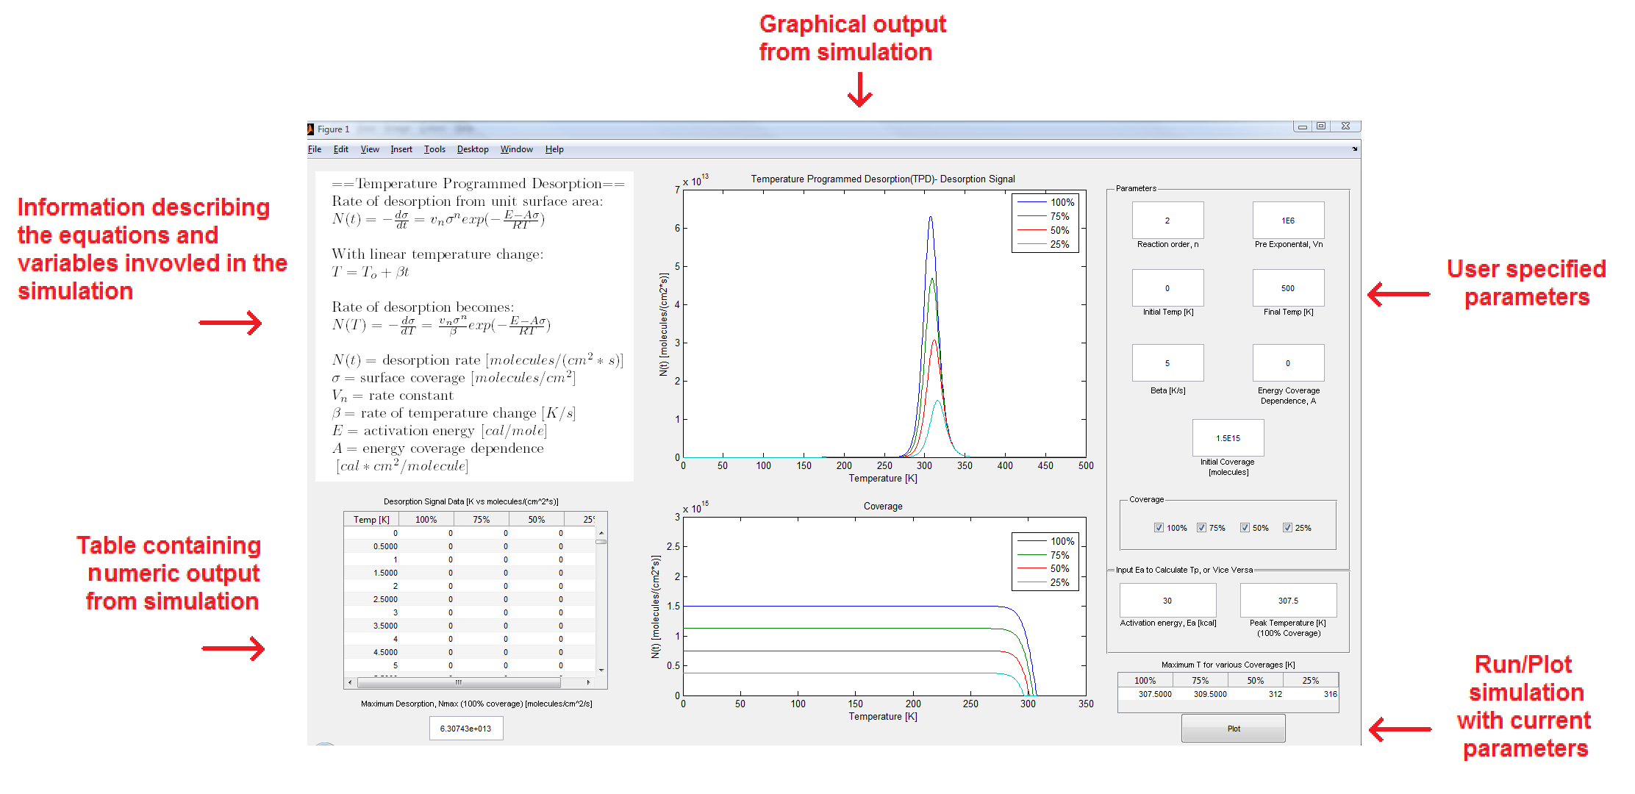

**Figure 2 - Simulation overview**

All simulations have a similar layout as that shown in Figure 2. The left hand side contains an introduction and background with equations and variables used in the simulation, as well as a table containing the numerical output of the simulation data. The center graphically represents the calculations made by the simulation. The right hand side contains a parameters box where users may specify the desired parameters to input into the simulated equation. The right hand side also contains the Plot button, used to begin the simulation after the user has completed editing the desired input parameters.

### Simulation Specific Instructions

#### TPD

This simulation has the most functionality and it requires some explanation on its use.

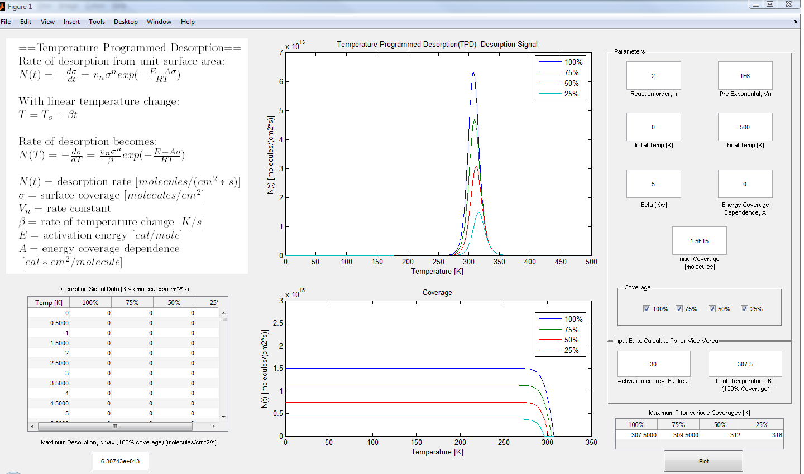

**Figure 3 - TPD simulation**

* Graphs
  + Desorption spectra (top graph)
  + Corresponding surface coverage spectra (bottom graph).
* Calculations
  + It can calculate a peak temperature from an activation energy, or vice versa. Once a user has entered a value into either of these fields, and presses ENTER, the other field will update with the corresponding calculation NOTE: If any of the parameters above are altered, the calculated TP or Ea will not update – one must press ENTER in the box of the known value, for the program to reassess the calculated value with the updated parameters
* Axes – change graph axes
  + The top graph axes can be altered by changing the Initial Temp and Final Temp values in the parameters panel
* Coverage
  + The checkboxes are used to graphically display the data for different percentages of initial coverage
* Reaction Order (Important)
  + One must be certain to set the proper value of the prexponential, v, as this varies with the reaction order. Typically,
    - n=0, v=1E 28
    - n=1/2 v=3.2E20
    - n=1, v=1E 13
    - n=2, v=1E –2

This simulation was modeled after the results of: Redhead, P., *Thermal desorption of gases.* Vacuum, 1962. **12**(4): p. 203-211. [1]

#### Layer

Models AES signals for FM mode of film growth. Equations adapted from: Koel, B.E. et al., *Growth mechanism and structure of ultrathin palladium films formed by deposition on Mo(100),*  Surf . Sci., 1992, **260**: p. 151-162 [2]

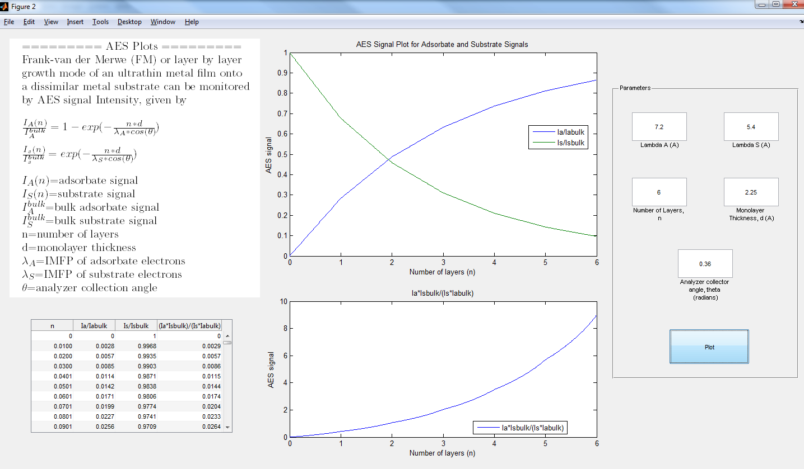

**Figure 4 - Layer simulation**

#### Langmuir

Models Langmuir isotherms. See p. 192 of our text: Kolasinski, K.W., *Surface Science, Foundations of Catalysis and Nanoscience*. 3rd ed. 2012, The Atrium, Souther Gate, Chichester, West Sussex: John Wiley & Sons, Ltd. [3]

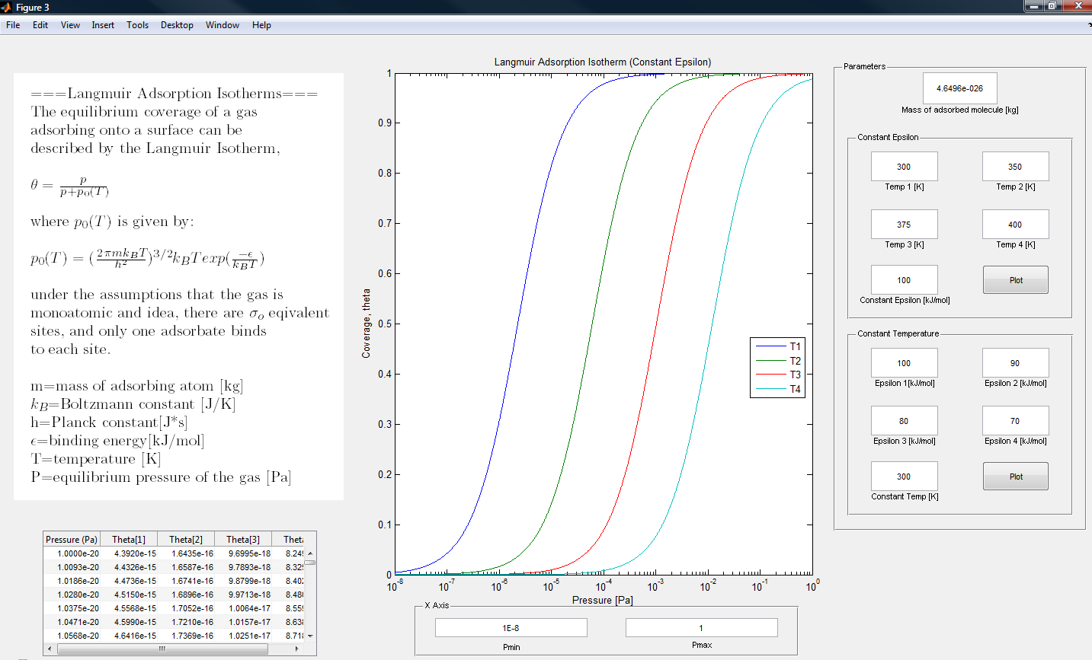

**Figure 5 -Langmuir simulation**

#### Sticking

Sticking coefficients for nondissociative precursor mediated adsorption. See p. 207 of our text: Kolasinski, K.W., *Surface Science, Foundations of Catalysis and Nanoscience*. 3rd ed. 2012, The Atrium, Souther Gate, Chichester, West Sussex: John Wiley & Sons, Ltd. [3]

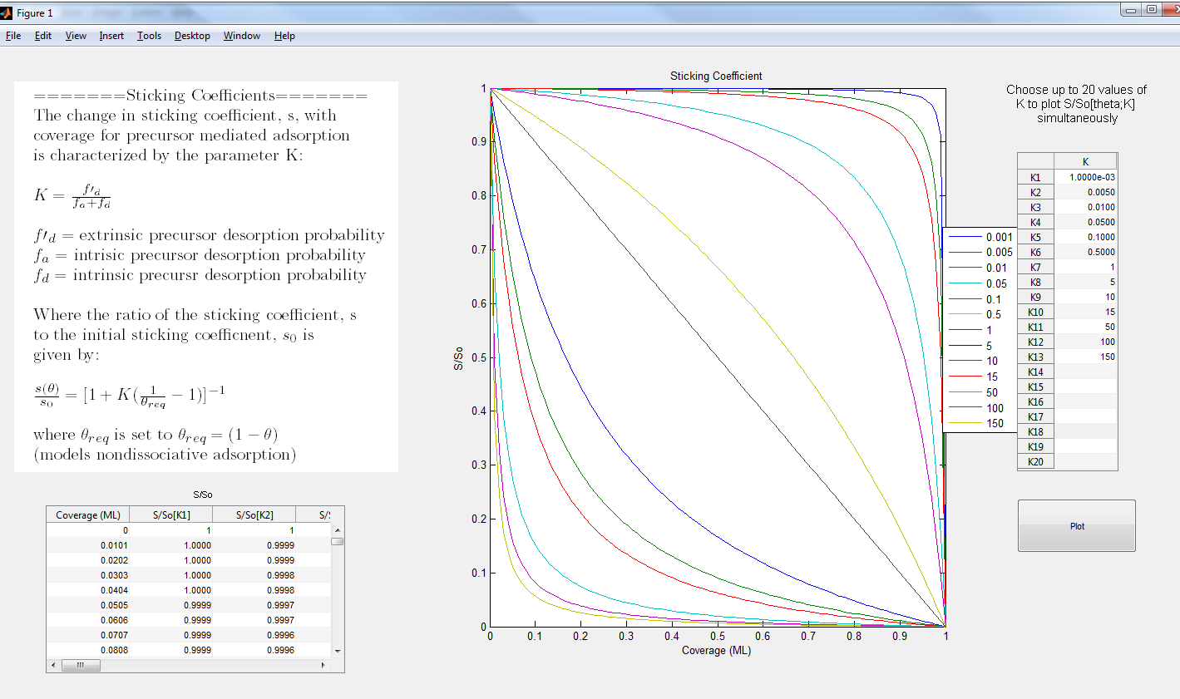

**Figure 6 - Sticking simulation**

# References

1. Redhead, P., *Thermal desorption of gases.* Vacuum, 1962. **12**(4): p. 203-211.

2. Koel, B.E. et al., *Growth mechanism and structure of ultrathin palladium films formed by deposition on Mo(100),*  Surf . Sci., 1992, **260**: p. 151-162

3 Kolasinski, K.W., *Surface Science, Foundations of Catalysis and Nanoscience*. 3rd ed. 2012, The Atrium, Souther Gate, Chichester, West Sussex: John Wiley & Sons, Ltd.